# The Leicester Food + Drink Trail

**Name:** Jen Kettle

**Student ID:** P2714765

# Introduction

My application, building on the concept that I devised for its initial design, is one whose core purpose is wayfinding for young adults between the ages of eighteen and twenty-five, specifically guiding them via a trail-like function to various restaurants and pubs in Leicester City Centre, with help from a partly-anthropomorphised, ever-present AR animal companion known as Les the Fox.

I’ve noticed at the university that several of my peers tend to make visits to pubs outside of session hours, which has prompted the choice for these to be one of the key types of food and drink establishments presented within the app; this also made me decide at the outset that, more specifically, those in the target age group who are in Leicester either as students or for work are the people my application is directed towards.

Also, something else I’ve noticed at the university is that some of the international students, or even those who are simply from outside of the county of Leicestershire, still have some unfamiliarity with the city of Leicester. Therefore, I decided that my main hope for the app is for its wayfinding purpose to help users like them to feel more comfortable and at home in the city, especially because students and young working adults are certain to experience stresses from their duties that would be exacerbated by living in a new, unfamiliar area.

# Testing

Once the coding of my prototype app had reached the stage where its key features – these being the navigation between pages, along with the desired AR elements – were successfully functioning, I then carried out the user testing. I had a total of two participants in this, the first having been Izaak De May, one of my peers, as he’s a student and this is one of the key characteristics of part of my target audience. As my app has a location-based aspect to its central, trail-like wayfinding function, me and both user testing participants went to The Globe, the pub in Leicester City Centre which became the sole location programmed into the app; the screenshot pictured below is a written-down extract of Izaak’s general thoughts on my prototype when asked afterwards.

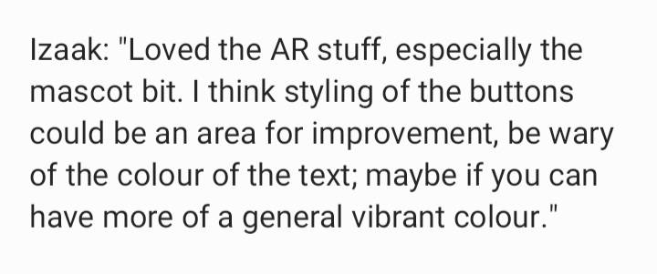

Next, the second of the two testing participants was Sam Hemmings, a contact of mine who isn’t a student himself but still fits the age range of my target audience, to gain a comparatively more diverse response. When asked about his own general thoughts on my prototype after testing it, he expressed the same opinion as Izaak, that the visibility on-screen text could’ve been improved, as due to the fact that some of this text content doesn’t have a background colour and is overlaid onto the camera-provided background, users might struggle with properly seeing the text depending on what background environment it’s presented on top of.

However, the first user testing response from Izaak had influenced me, before Sam’s participation, to program background colours for all of the navigation buttons at the top of the screen on each of the app’s pages, as well as for the home screen welcome text suggested to be provided by Les the Fox, for visibility improvement purposes. This decision was further compounded by feedback that I received from a presentation I gave of my prototype, also suggesting some potential changes to the navigation features to make them more prominent.

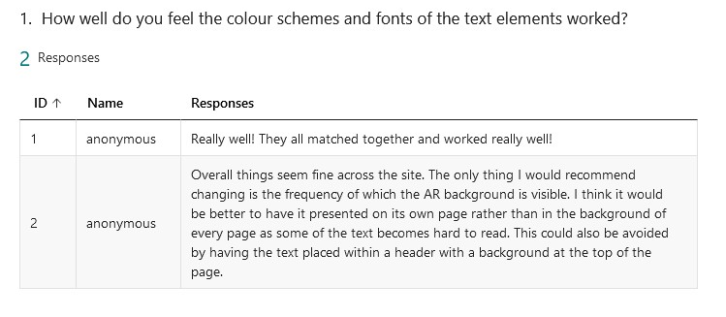

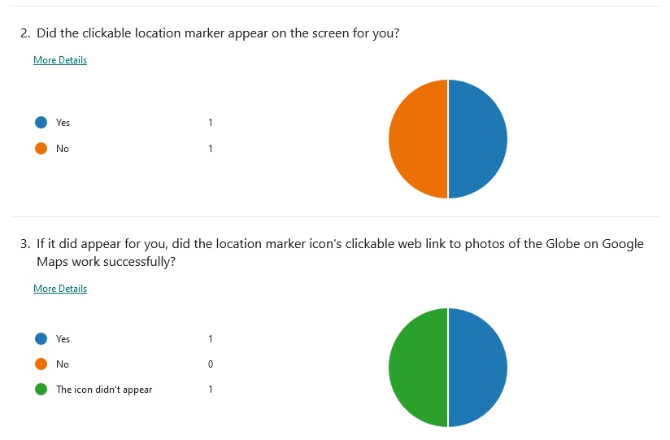

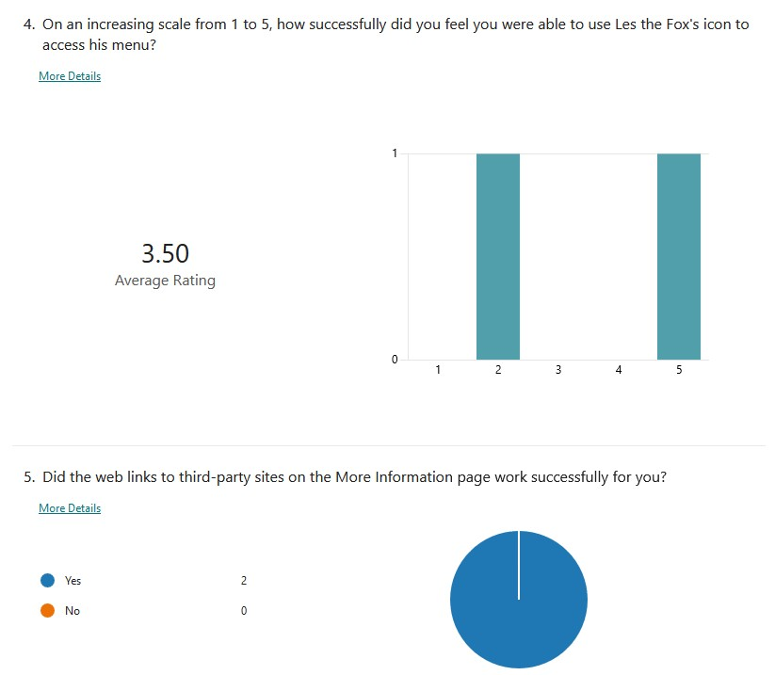

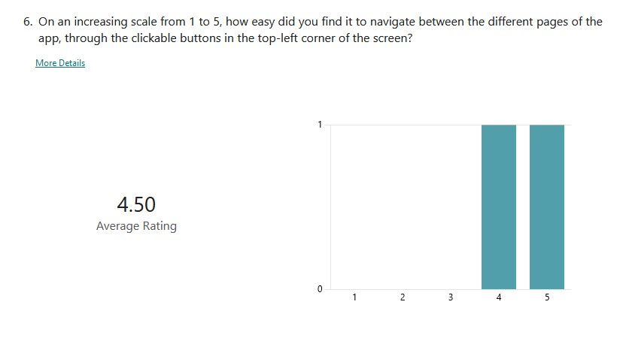

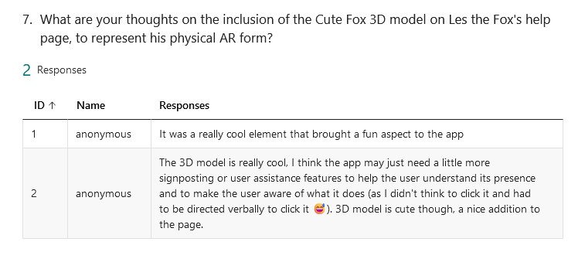

These survey results from Izaak and Sam pictured above have successfully provided further insight into the positives and pitfalls of my app’s prototype. For example, I’ve learned both from their answers to Question 2 and from observing the testing itself at the time that whether or not the augmented reality aspects appeared for them differed due to them carrying out the testing on different smartphone models – I myself was unable to find the clickable location marker or any of the other AR elements on my own phone, like Izaak’s answer to the question.

It seems that the answer provided by Sam to Question 1 seem to illustrate another improvement I could’ve made, in relation to the remaining text elements which I *didn’t* give background colours to in the end. Furthermore, his answers to Questions 4 and 7 suggest that although the icon of Les the Fox was itself visible enough on the screen of a phone, its nature as a clickable feature button which leads to what’s intended to be his help page was unknown until I verbally told him during the testing. This means that this feature could’ve been made more user-friendly via consistent guidance across the app making the icon’s purpose more obvious, such as in the form of more on-screen text which would encourage the user to click on it.

I followed this stage up by carrying out my technical testing of the app, to see whether there were any remaining errors within the code after my having finished creating the prototype’s end result. I started this out by running the app’s URL through Google Chrome’s DevTools, which is what provided the three screenshots below. Although the DevTools listed errors in some places across the HTML pages, these were few and far between and fortunately appeared to have been minor enough to have not caused any notable problems during the user testing. The Preferences page, or, more accurately, what was *intended* to be the Preferences options page but ultimately housed placeholder text, appears to contain the most code errors in comparison to the other pages. This has provided me with some insight into why the Preferences screen’s programmed camera mode failed to work when tested on smartphones while those of every other page worked, except for Les the Fox’s Menu, which was deliberately coded to not have a camera mode.

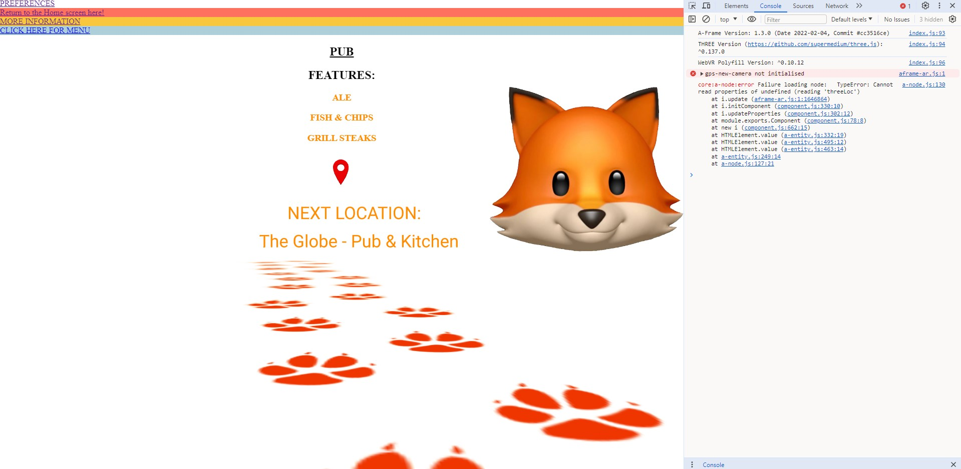

*The Main Trail Function page with the DevTools tab open for it; there’s a singular coding error, which seems to lie with the GPS camera command.*

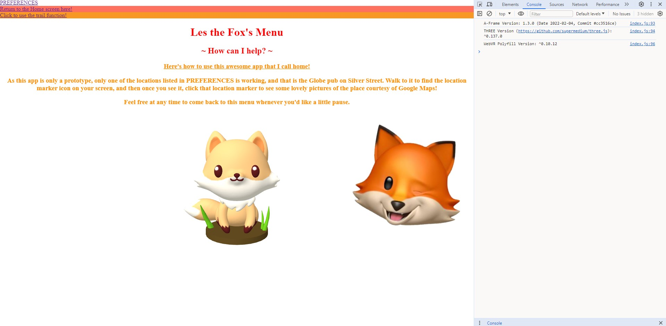

*Les’s help page in Chrome’s DevTools tab, which is saying that there are no errors at all on this page.*

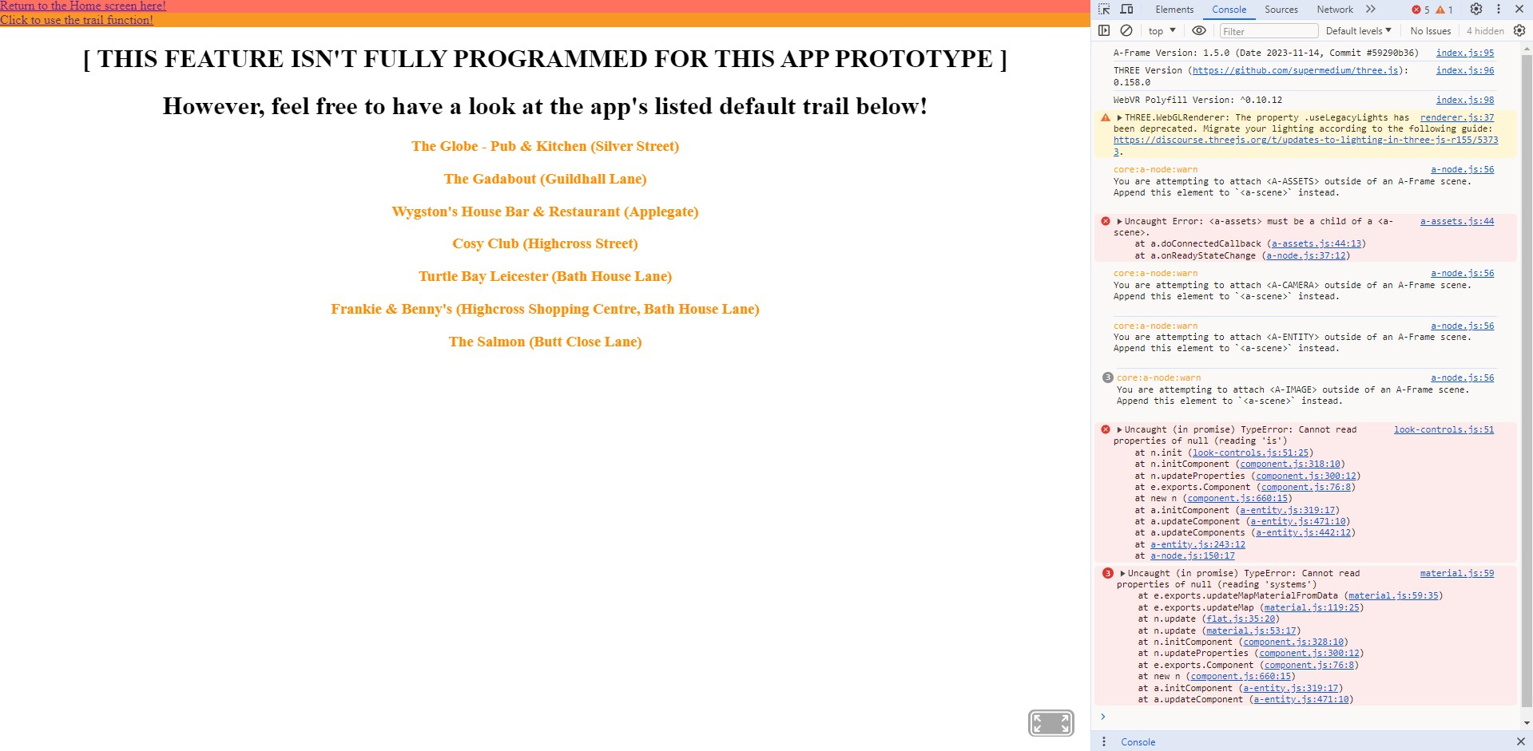

*The prototype Preferences page, which was found through its own part of the DevTools technical testing to contain five errors and one warning in its code.*

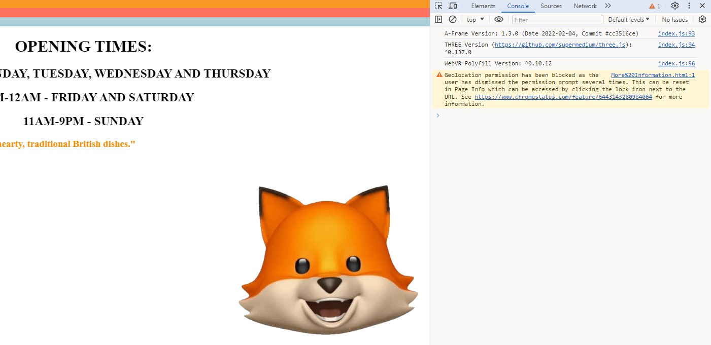

*DevTools’s sole listed warning on the More Information page, which was simply caused by me rejecting the GPS option when the page loaded due to the fact that this was tested on a computer rather than my phone.*

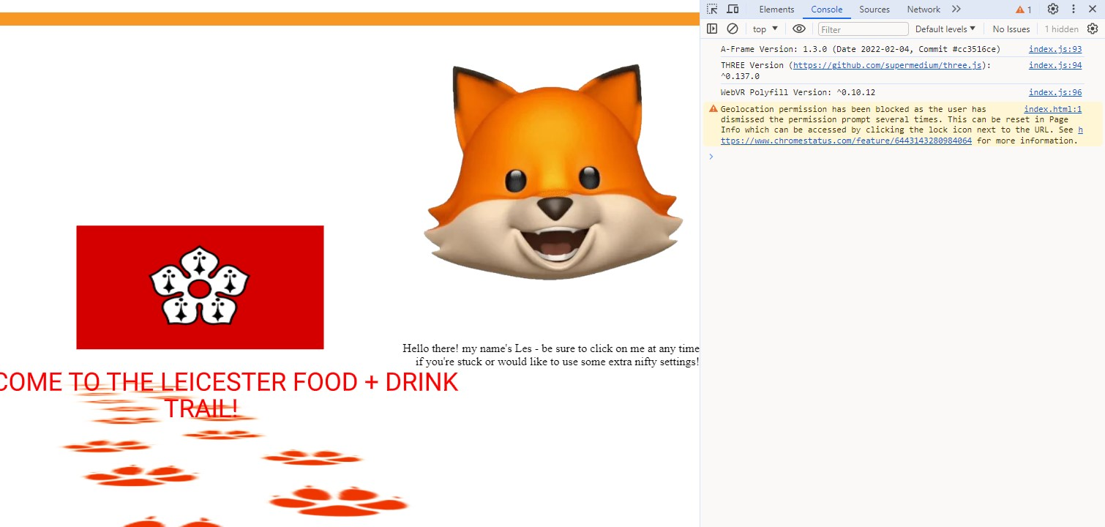

*The home screen page of the app, or rather my index page as it’s known in its file name and URL, also listed only one warning and no other errors like More Information above, with it being the exact same warning.*

I also ran the code of each of my app’s pages through Nu HTML Checker, which listed potential errors and warnings for them in sequential lines all presented one after another. After reading what these discovered errors were – all of them being pictured below – I rectified number 6 for my index page, numbers 1-5 and 9-13 for Preferences, and 1 for LesMenu.

All of these were noticed via Nu having been quite helpful in pointing out to me where I’d made small HTML attribute typos, such as accidental plus signs rather than quotation marks in some of the meta http-equiv lines as well as

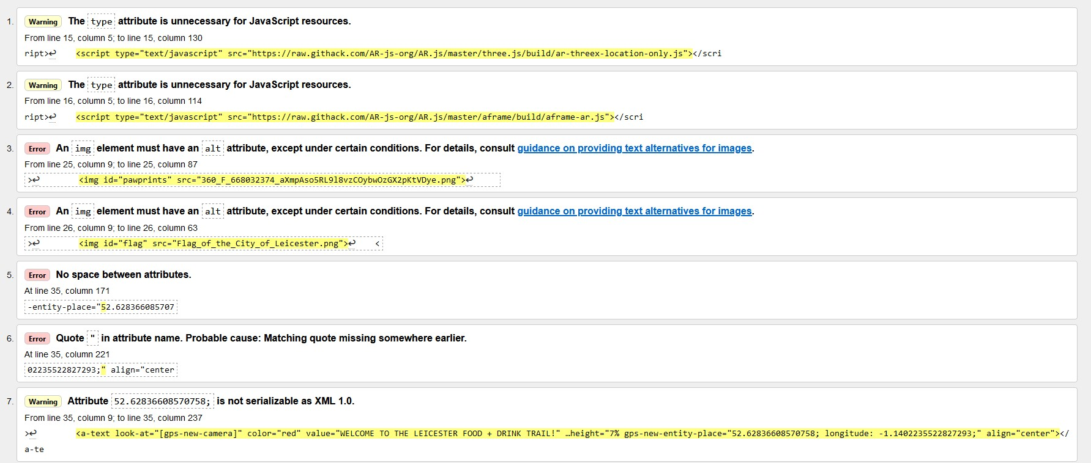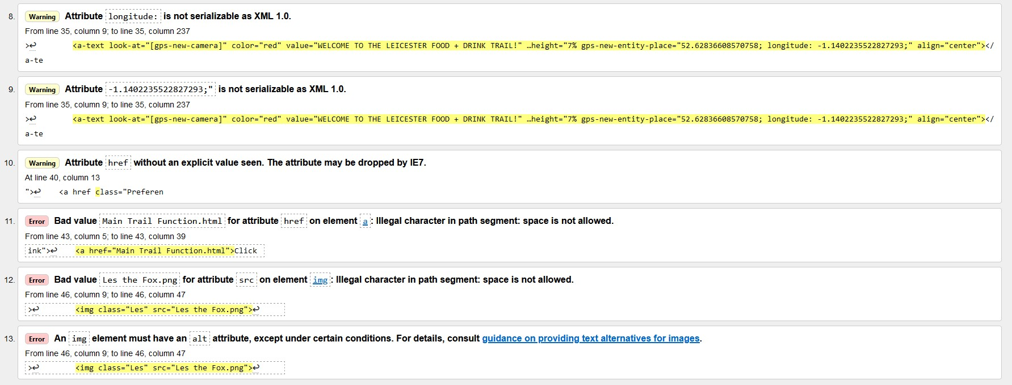

*The errors for the app’s index page, coming to a total of thirteen.*

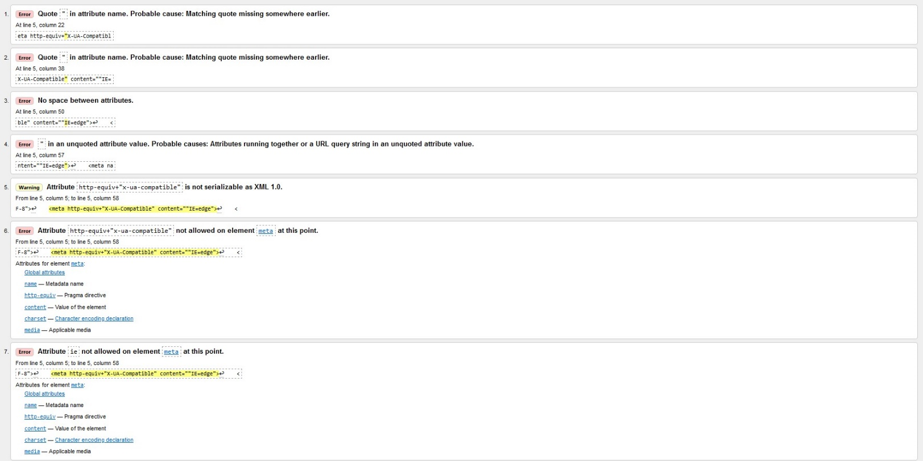

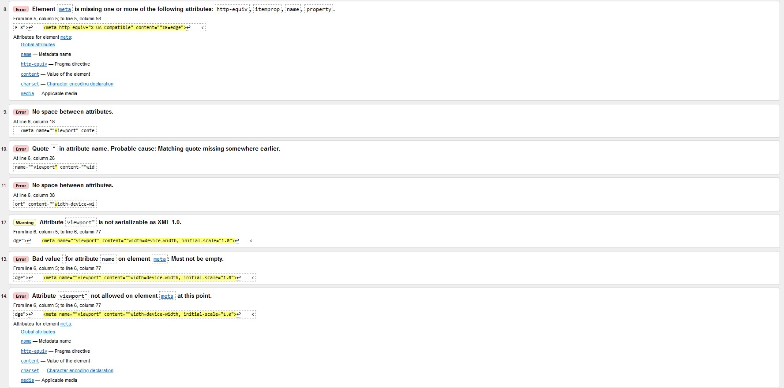

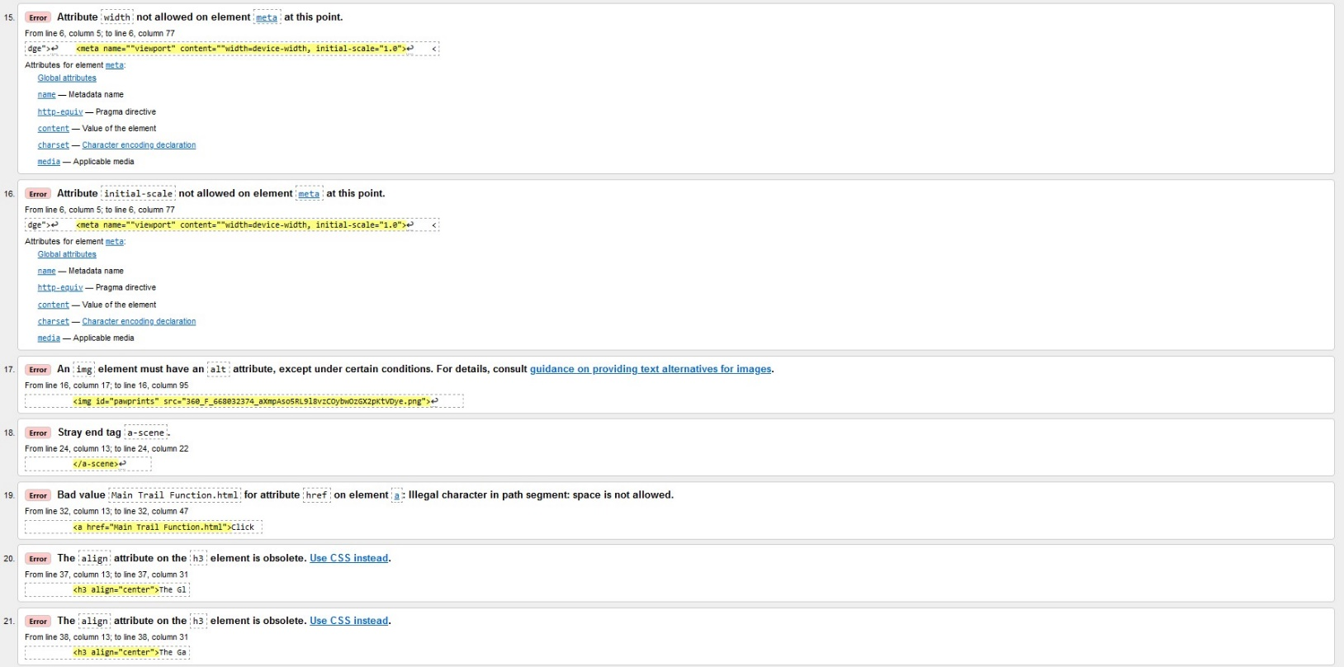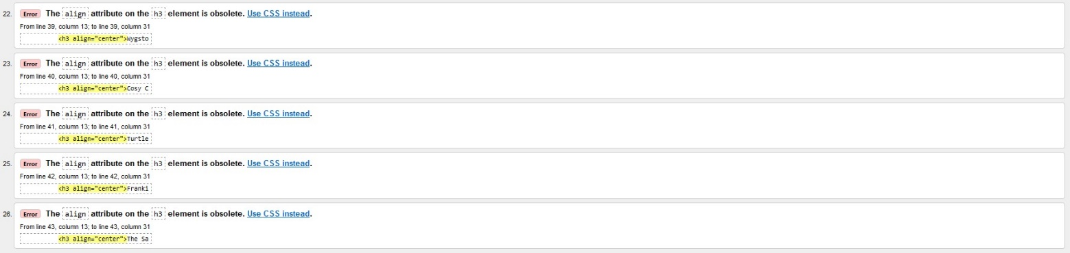

*The total of twenty-six errors listed by Nu for the Preferences page, serving as further indication that this page is the one with the most errors compared to the others.*

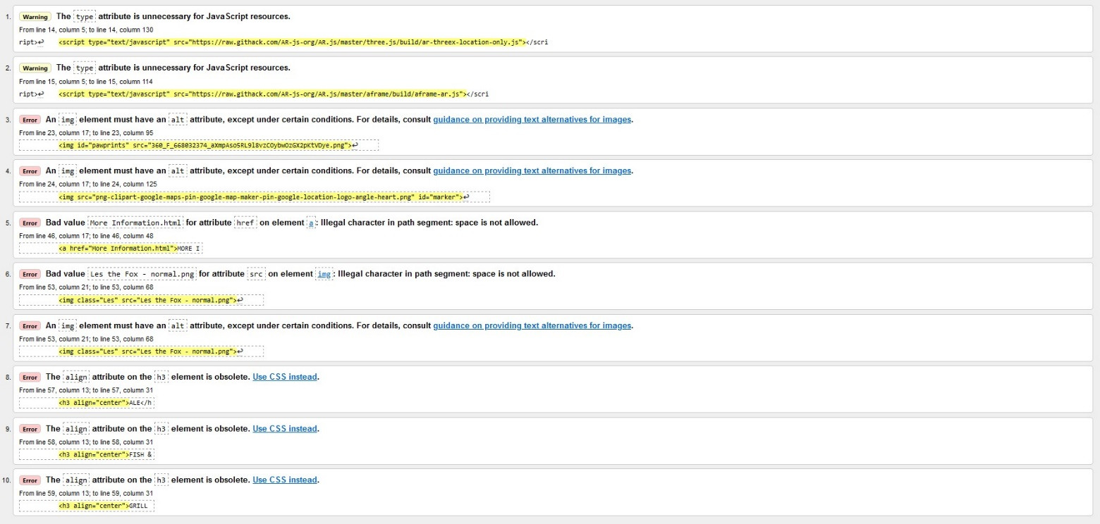

*The ten errors from Nu for the Main Trail Function page.*

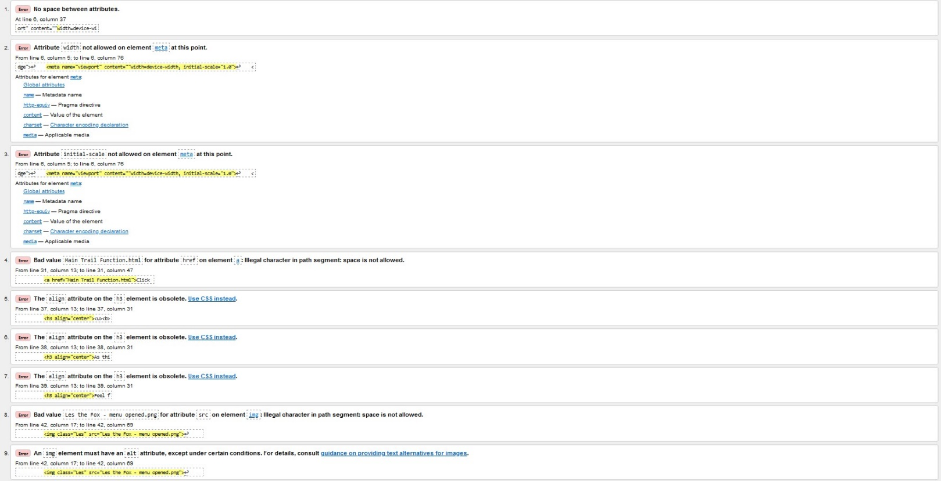

*The list of nine errors on the LesMenu page.*

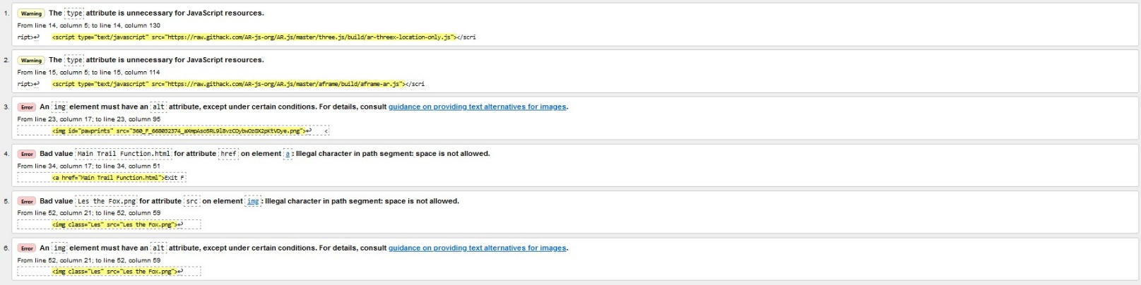

*Nur’s six discovered errors within the More Information page – just like it was indicated beforehand in Chrome’s DevTools, this still seems to be the page of the app with the least errors in its code.*

# Evaluation

It’s my belief that, overall, my prototype app project has worked successfully, to a degree where I’m quite happy with the result. This final thought of mine is partly, in addition, due to my lack of experience with coding except for last year and how difficult I seem to have found learning how to implement the correct code for the AR elements. The other people whom I asked about my prototype, such as the two who participated in the user testing stage, have also said as shown by said testing’s survey answers pictured above that – with the exception of a few alterations that could’ve been made for further improvements – the app is of good quality, and have provided generally positive documented responses.

I did find the process of getting to this point troublesome, though, and at times severely struggled with programming the prototype’s augmented reality aspects. Some of this was in part because of the fact that my mobile phone, which I tried out the app on several times prior to the user testing, didn’t display the majority of the AR apart from the Cute Fox 3D model used on Les’s help page, and as outlined in the Testing section, I was unaware that this fact was dependent on the difference in models of different smartphones until Sam Hemmings took part in the testing. Speaking of which, by the time the project was finished I only had a total of two user testing participants, a number which I would’ve endeavoured to be larger if it were for a professional, commercial product. Because of these struggles that I’ve had with the coding, although it hasn’t detracted from how happy I am with the end result it’s meant that the app itself has become visibly watered down from my original concept design. However, due to it being intended simply as a working prototype rather than a commercial-grade product, I think that this can somewhat excuse some of these ultimately diminished characteristics.

The location-based trait of the app’s core function itself was possibly what caused quite a few of my issues with properly implementing the desired programming, as my idea was for the pawprints to lead the user from their current location to where the next pub or restaurant on the trail is and then disappear once they arrived. Because of the extent of my coding capabilities, this became one of the aforementioned characteristics from the original design that was watered down in the end. However, every third-party webpage link that I implemented appears to work successfully, contributing to my belief that my app has worked well on the whole. In future, some of the issues I had could be rectified or even avoided altogether by further studying how to carry out AR coding through sites like W3Schools and A-Frame.

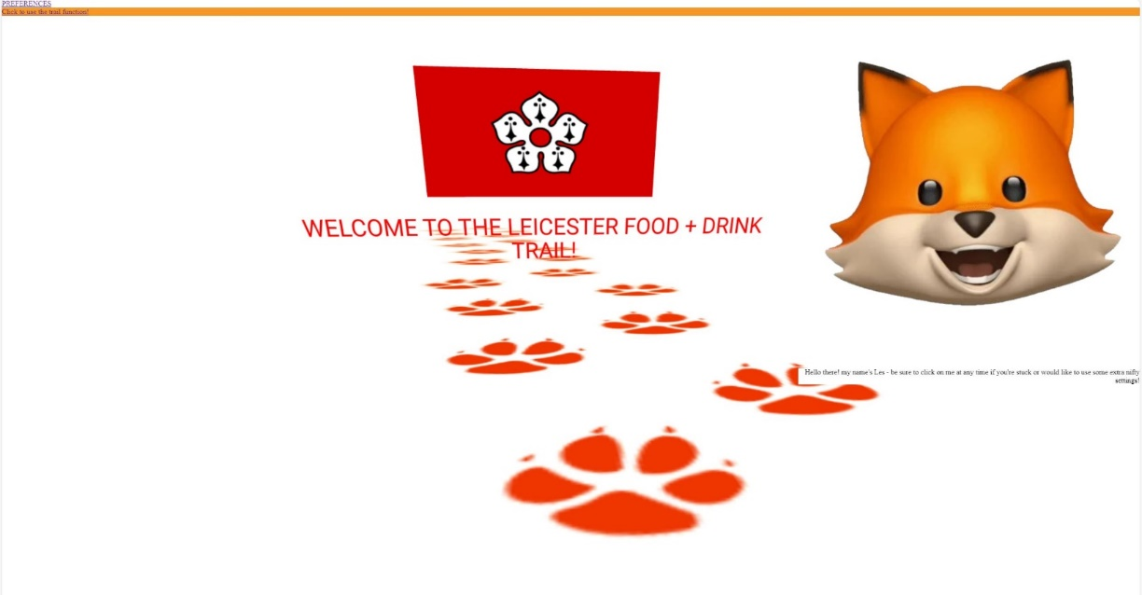

*The home app’s home screen, presenting Les the Fox’s welcome text and various AR elements.*

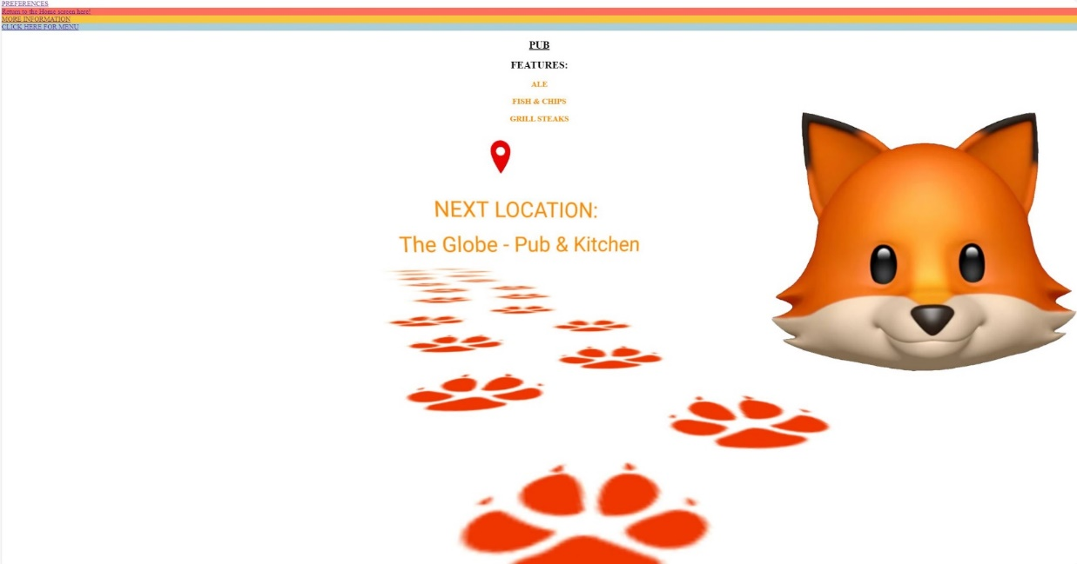

*The screen of the app’s main wayfinding function itself – note the four navigation button lines with different background colours, which has been implemented following Izaak De May’s suggestion for more vibrance. Also, this and the home screen are jointly the two pages of the app which contain the most AR elements.*

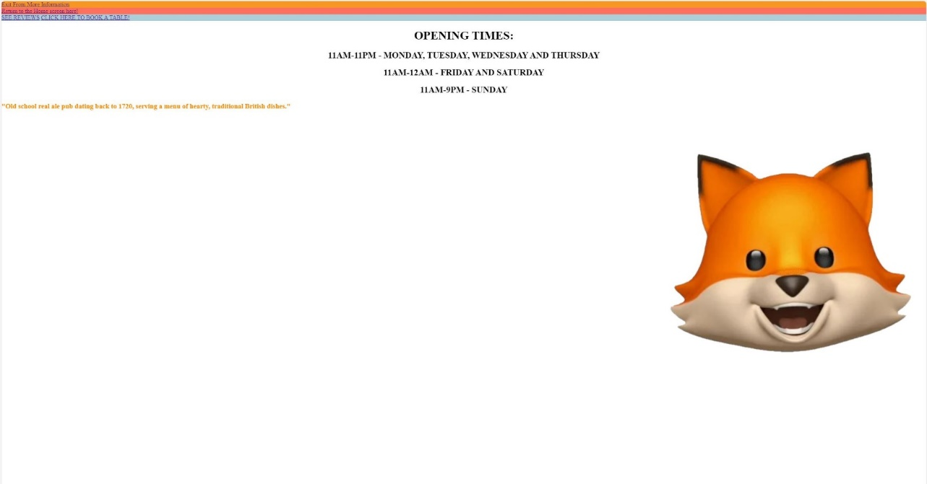

*The More Information page, which is an extension of the previous, main function page.*

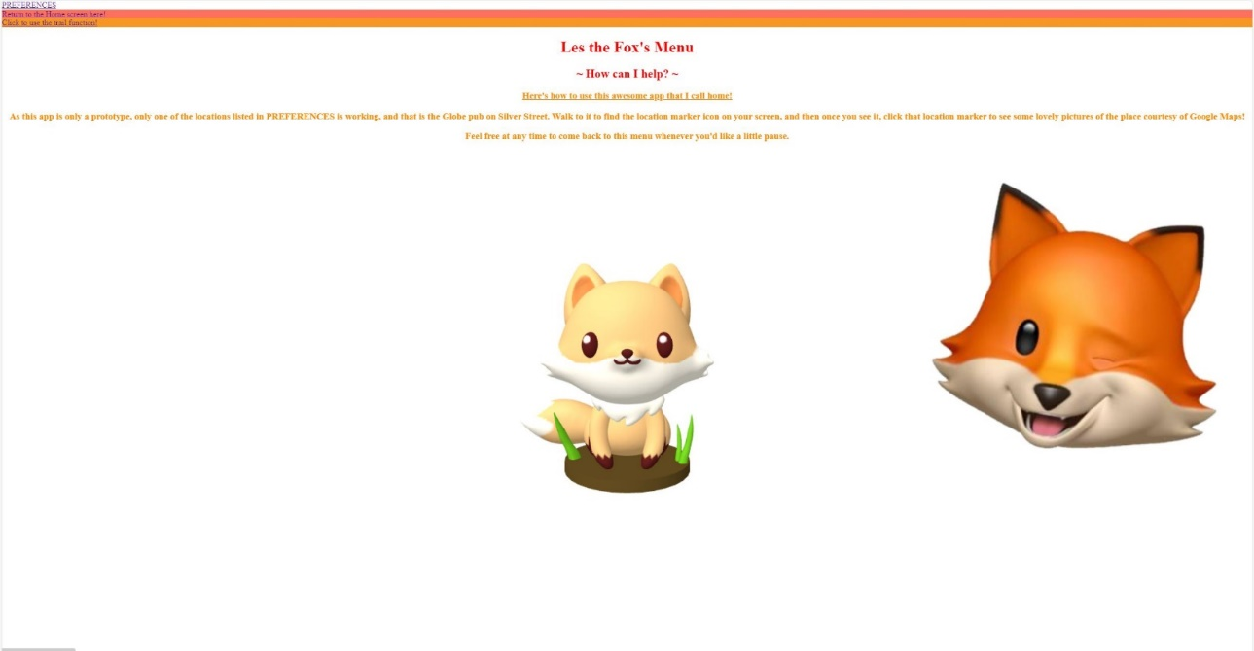

*Les the Fox’s Menu, which was originally designed in the initial concept to contain more features such as adding a location to the user’s favourites. The other difference to the initial design is the pictured inclusion of a 3D model to represent his physical AR form, as though he genuinely does reside on this page.*



*The Preferences page, which is the most blank compared to the other pages due to the number of selectable features from the original design that had to ultimately be omitted. All of these images of the pages’ screens were taken when the live view from Visual Studio Code was active during the coding.*